**Loan Analysis**

**Background**

Using the Universal Bank data, determine the factors that influence whether a customer takes out a loan.

**Resources**

Use the data set SCM 651 Homework 4 Universal Bank spreadsheet.

**Assignment**

**What’s due:**

Submit a logit, probit, and neural network analysis of loan acquisition behavior **before the live class in week 10**. Suggested length is 5 pages but should not exceed 10 pages, single-spaced, 12-point font.

This is a group assignment; each student should upload a copy of the assignment to the learning management system. The paper must be a Microsoft Word document. You should also submit the Excel spreadsheet with the prediction models and sensitivity analyses. Name the file HW4_Team# where # is your team number. Be sure to include the names of everyone on the team on the first page of the paper. Late assignments will not be accepted. Failure to follow directions will be penalized.

**Outline and grading criteria:**

1. Perform a logit and probit analysis of the variables that affect whether a customer takes out a loan. Consider only main effects (main variables, no moderating effects). Which variables are significant? How do the significant variables influence the likelihood of taking out a loan? Copy screen snapshots of your analysis in R to your report. (20%)
   1. The significant variables are CCAvg, CDAccount, CreditCard, Education, Family, Income, Online, and SecuritiesAccount.
      1. For CCAvg, as the CCAvg goes up, the likelihood of getting a loan will increase.
      2. For CDAccount, as the CDAccount goes up from 0 (no) – 1 (yes), the likelihood of getting a loan will increase.
      3. For CreditCard, as the CreditCard goes up from 0 – 1, the likelihood of getting a loan will decrease.
      4. For Education, as the Education goes up from 1, to 2, to 3, the likelihood of getting a loan will increase
      5. For Family, as the Family number goes up, the likelihood of getting a loan will increase
      6. For Income, as the Income goes up, the likelihood of getting a loan will increase
      7. For Online, as Online goes up from 0 – 1, the likelihood of getting a loan will decrease
      8. For SecuritiesAccount, as the SecuritiesAccount goes up from 0 – 1, the likelihood of getting a loan will decrease

**Logit Results:** 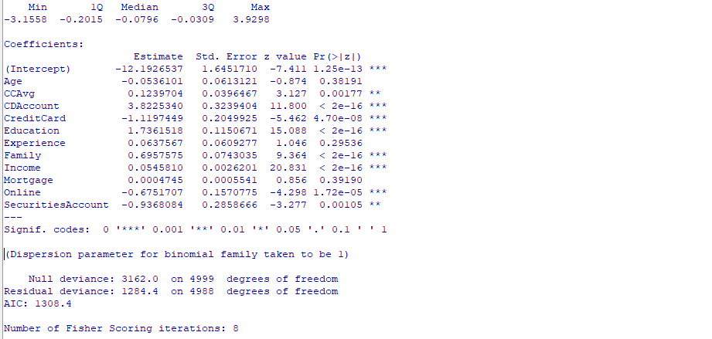

**Probit Results:**

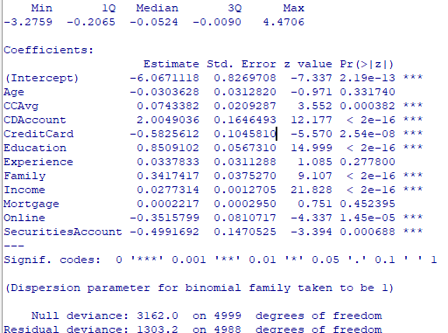

1. Add moderating effects (interactions of variables). Which interactions make sense

conceptually? Which interactions are statistically significant? How do you interpret the coefficients on these variables? Copy screen snapshots of your analysis in R to your report. (20%)

Conceptually, the variables of Family interacting with CCAvg, and Education interacting with Income seems to make the most sense. The interactions of variables that make sense conceptually CCAvg and Family size. The more often an individual is using the credit card and carrying a balance and the larger the family size, the more likely that individual is to need and accept a personal loan. In addition, Education and Income also makes sense conceptually because an individual that has a higher income and a high education is more likely to accept a loan versus paying in full upfront because it is financially responsible to leave funds in a high interest savings account that gains interest and be able to qualify for a low interest or zero interest loan and pay it back over time without any cost to the applicant.

The interactions we found to be statistically significant are Education and Income. The result of the R Analysis are shown below.

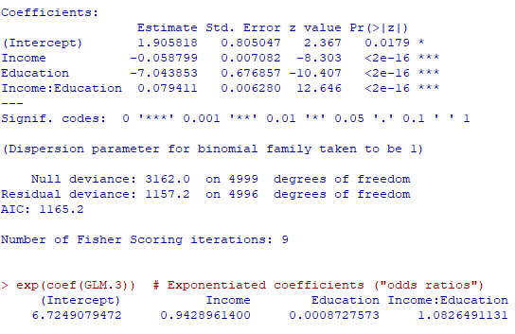

1. Create a final regression model with the variables that you feel are important (both main effects and interaction terms). Use the moderating effect that was significant and its two individual main effects. Create a spreadsheet prediction of the model. Perform a sensitivity analysis as seen earlier in the semester. Which variables have the greatest influence on the customers’ loan behavior (combined main effects and interaction effects)? Copy screen snapshots of your analysis in R to your report. (Color Coat it) (20%)*****
   1. The variables with the greatest influence on the customers’ loan behavior are education and income.

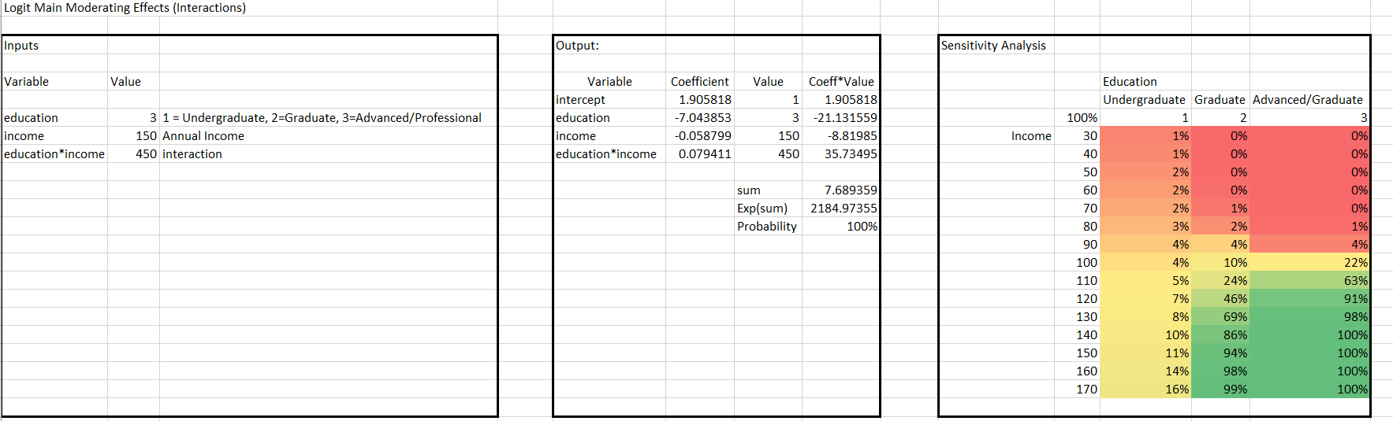

1. Perform a neural network analysis of the variables in part 3 above. Copy screen snapshots of your final neural network model in R to your report. (20%)
   1. loannet <- neuralnet(PersonalLoan ~ Education + Income, loan, hidden=2, lifesign="minimal", linear.output=FALSE, threshold=0.01)

plot(loannet)

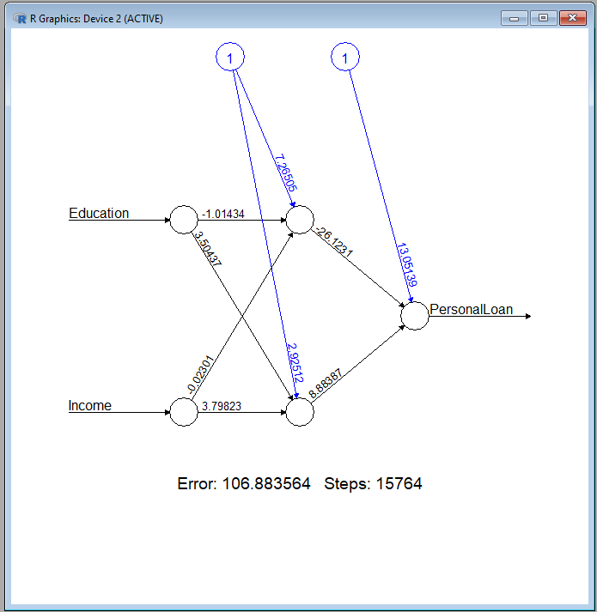

1. Create a prediction model of the neural network in part 4. Using the prediction model, perform a sensitivity analysis for the neural network model like the logit and probit sensitivity analysis. (20%)

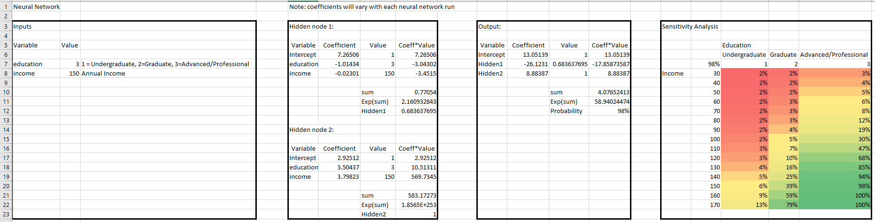

Justify your answers. Provide a snapshot of output from your analysis in your final paper.

**Universal Bank Data Fields**

ID unique identifier

Personal Loan did the customer accept the personal load offered (1=Yes, 0=No)

Age customer’s age

Experience number of years of profession experience

Income annual income of the customer ($000)

Zip code home address zip code

Family family size of customer

CCAvg average spending on credit cards per month ($000)

Education education level (1) undergraduate, (2) graduate, (3) advanced/professional

Mortgage value of house mortgage ($000)

Securities does the customer have a securities account with the bank? (1=Yes, 0=No)

CDAccount does the customer have a certificate of deposit with the bank? (1=Yes, 0=No)

Online does the customer use internet banking facilities? (1=Yes, 0=No)

CreditCard does the customer use a credit card issued by Universal Bank? (1=Yes, 0=No)

Two Similarities

Two Differences

One similarity, one difference

Logit vs Probit Final Exam